Social Cohesion HRM

working

Chungil Chae

Sat, 2 November 2024

Table of contents

# Project Details

Updated in 2021-09-01

## Citation

## Abstract

Here Abstract

## Planning

### Schedule and Due Date

* Idea Development
  + November 30, 2024
* Literature Review
  + December 29, 2024
* Tentative Analysis
  + January 12, 2025
* Proposal
  + January 31, 2025
* Abstract for Spacial Issue Editorial Board
  + February 1, 2025
* Full Analysis
  + February 16, 2025
* Rough Draft
  + March 9, 2025
* Final Draft
  + March 31, 2025
* Submission
  + April 1, 2025 (submission window 1-30)

### Progress

* Progress 1
* Progress 2

## Authorship and Authors

### Author Contribution

* Supervision: Chungil (Chad) Chae
* Project administration:
  + Chungil (Chad) Chae
* Conceptualization:
  + Chungil (Chad) Chae
* Data accusation:
* Data curation:
* Formal analysis:
* Chungil (Chad) Chae
* Investigation:
* Methodology:
  + Chungil (Chad) Chae
* Resources:
* Validation:
* Visualization:
* Writing – original draft:
  + Chungil (Chad) Chae
* Writing – review & editing:
  + Chungil (Chad) Chae

### Authors

#### Chungil Chae, Ph.D., M.S.

* chadchae@gmail.com
* orcid: [000-0002-7364-1525](https://orcid.org/0000-0002-7364-1525)
* [Google Scholar](https://scholar.google.com/citations?user=c4lRBrkAAAAJ&hl=en)
* CBPM
* Wenzhou-Kean University

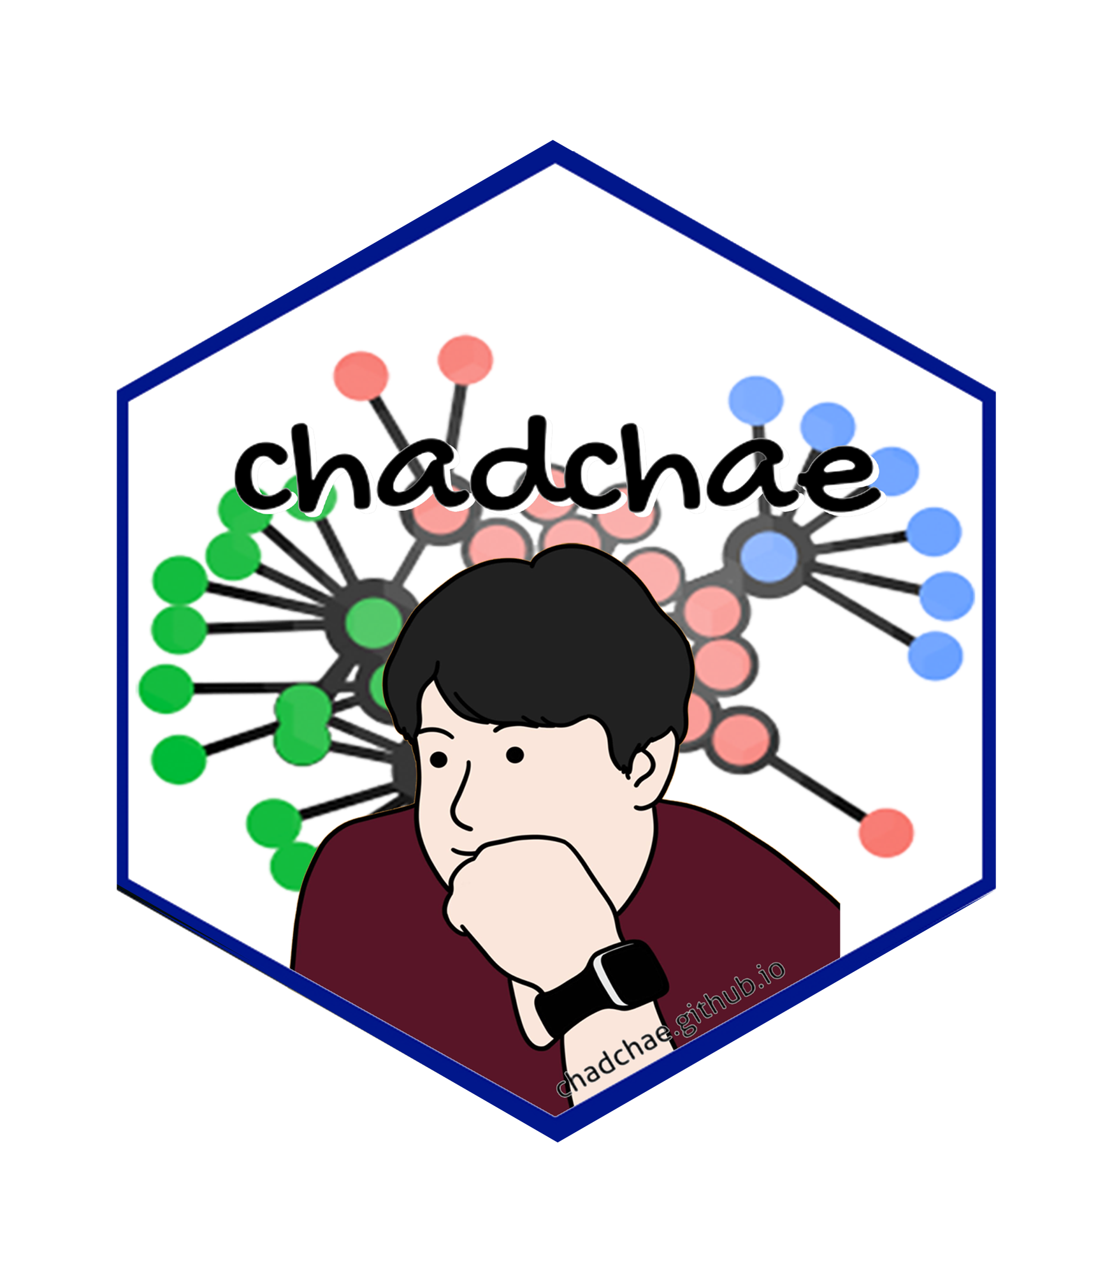

Chungil Chae Chae (2024) is an assistant professor in the field of business analytics, with a distinguished track record in organizational behavior, human resource development (HRD), learning, and development. With a prolific publication record that spans various dimensions of HRD and organizational studies, Dr. Chae has made significant contributions to understanding the dynamics of organizational support on knowledge sharing, virtual team leadership, and the structural determinants of HRD research collaboration networks. And his work embodies a deep commitment to enhancing understanding and practices in organizational behavior, HRD, learning, and development. His interdisciplinary research not only contributes to academic discourse but also offers tangible strategies for organizational improvement and individual development.

#### Jiongcheng Lu, M.A.

* lujiongcheng1@gmail.com
* orcid: [0009-0000-4470-8818](https://orcid.org/0009-0000-4470-8818)
* [Google Scholar](https://scholar.google.com/citations?user=KYyei4sAAAAJ&hl=zh-CN&oi=ao)
* University of Sydney Business School (Finance discipline)
* The University of Sydney

image or logo

Jiongcheng Lu (Tony) have a diverse background that combines both industry experience and research expertise. He have interned at banks, investment institutions, and technology research institutes, gaining a broad understanding of finance and innovation. Additionally, Lu founded his own tech company, which provided valuable entrepreneurial experience. Jiongcheng Lu’s research focuses on health economics, financial accounting, and healthcare accessibility, with a strong emphasis on quantitative methods. He is particularly interested in applying econometrics and machine learning techniques to address complex challenges in finance.

### Acknowledgement

* tba

## Declearation

### IRB

### Funding

### AI

# Research Log

## xxxx-xx-xx

* entry.

# Meeting Log

## xxxx-xx-xx

* ☒ 10:00-10:30: Kick-off meeting

# Analysis Version

## Version 0.0.1

* Starting draft

# Draft Version

## Ver 0.0.1

* Starting draft

# Ideas and Thoughts

# Research Q & A

# Procedures

# Related Theories

# Theortical Relationship

# Theoritical Framework

## Hypothesis

# Methdology

# Method

# Data Collection

# Data

# Searching and Inclusion & Exclusion

# Round 1

## Search kewwords and category

## keywords combination

# Round 2

## Search kewwords and category

## keywords combination

# Round 3

## Search kewwords and category

## keywords combination

# PRISMA

# Reference List

Category, Classification and Decision Note for Selected Literature in Rounds

## Round 1

## Round 2

## Round 3

## Additional (during and after writing)

# Reserach Problems

# Key References

# Quotes and Paraphrases

# Products

# References

Chae, C. (2024). *Introduction to chad (chungil) chae*. <https://chadchae.github.io>