Grow What’s Visible, Reduce the Workforce: How Informal Competition Quietly Reshapes Firms
Chungil Chae
Mon, 29 June 2026
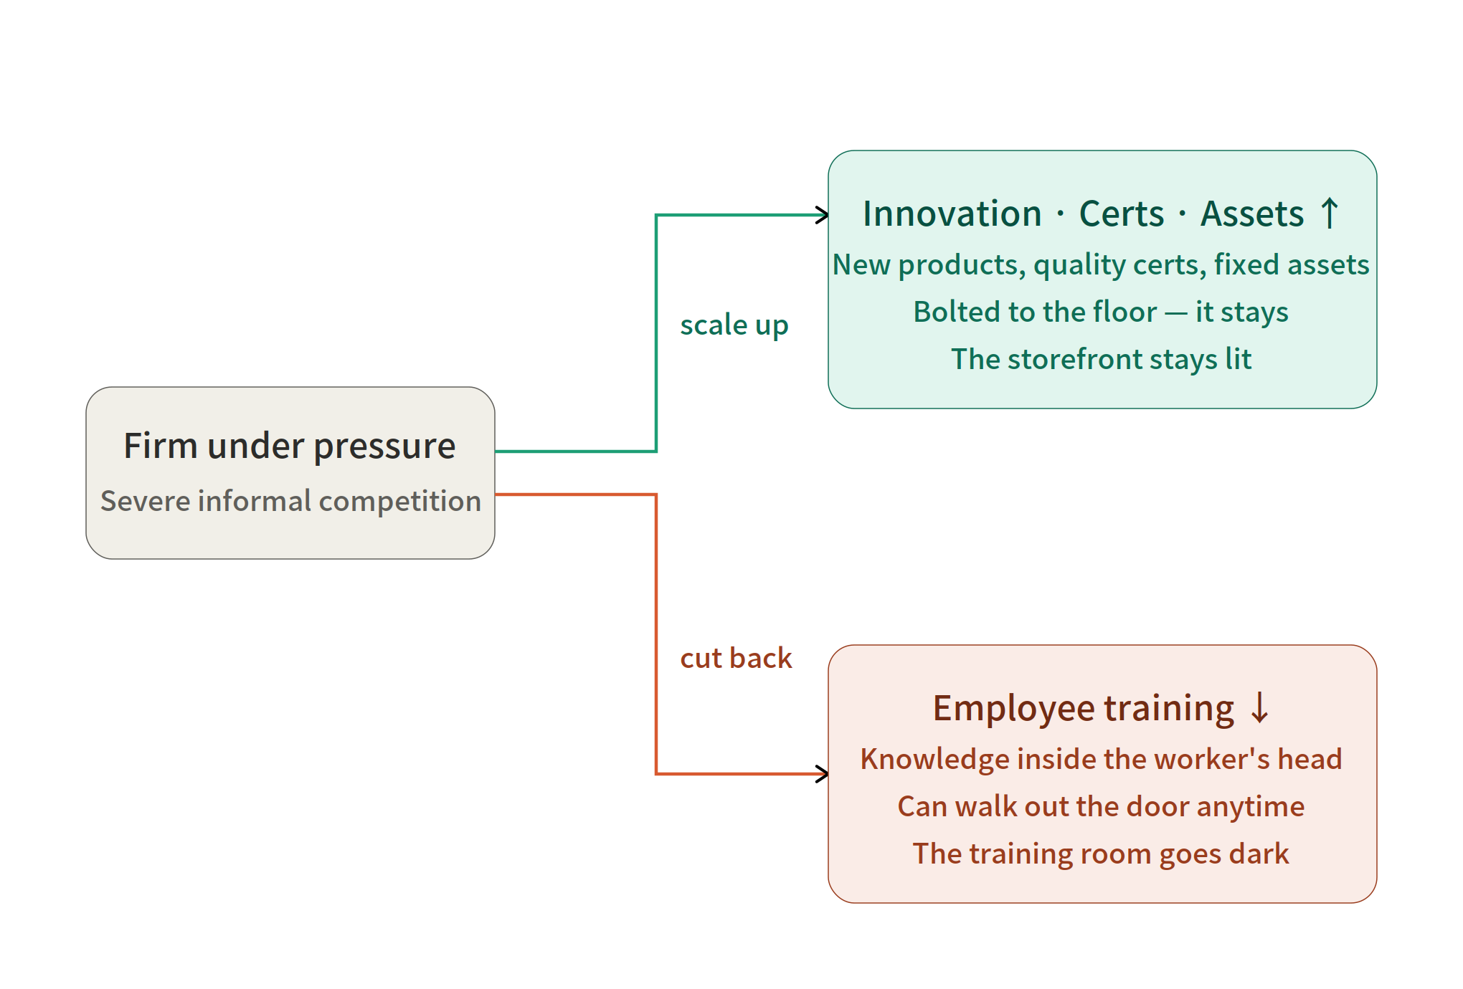
Original Paper: “Competency Enhancement Without Workforce Development Under Severe Informal Competition” (Lu, Xu, Chen, Jin, Wang, Wu, & Chae — Wenzhou-Kean University / UCL)

Introduction: A Scenario
There is a registered company. It pays taxes, complies with labor laws, and maintains proper documentation. But across the street is a competitor that avoids paying a significant portion of those costs: unregistered businesses in the informal sector. More than 60 percent of global employment falls within this informal sector, and in low-income economies, the figure approaches 90 percent (ILO, 2018).
This is not a competition played by the same rules. It is a competition where the rules themselves are different.
Every year, the CEO of this company faces the same questions: Should we spend money on employee training? Should we buy new machinery? Should we pursue quality certification? This article traces the patterns behind those choices. And those patterns turned out to be the exact opposite of what we initially expected.

Question 1: What is happening?
Common sense suggests that when competition intensifies, companies do one of two things: they either invest everything to survive, or they pull back and weather the storm. Whether it’s training, innovation, or assets, investments in capabilities move as a single package. This has long been a fundamental assumption in strategic HRD research (Garavan et al., 2016; Mathias et al., 2021).
The data has unraveled that bundle.
Faced with intense informal competition, companies did not stop upgrading. They launched new products, obtained quality certifications, and purchased fixed assets. However, they quietly cut back on just one thing—employee training.
What We Expected | What the Data Showed
Under pressure, companies cut investment across the board | Innovation, certifications, and assets remain unchanged; only training is reduced
Training and upgrading move in tandem | The two diverge (selective decoupling)
Only weak, cash-strapped companies fail to invest in training | In fact, high-performing companies cut back even more
This is the term the study coined: selective decoupling. They expand what’s visible and cut back on people.

Question 2: Why Does This Happen?
The answer boils down to one word: appropriability—can I retain the fruits of my investment until the very end?
Here comes the most accurate analogy in this article.
New machinery is bolted to the floor. Quality certificates are issued in the company’s name. However, training is stored in employees’ minds, and they can walk out the door at any time.
Let’s map this out one-to-one.
Concept | Analogy
Non-HRD upgrading (innovation, certification, assets) | A machine bolted to the floor — it won’t leave
Formal training | Knowledge in an employee’s head — it walks out the door
Low appropriability | There’s a hole through which the fruits can leak out
Rule-asymmetric competition | The wind that widens that hole
Training is expensive and time-consuming, and when skilled employees leave, that value leaves with them. In an environment where low-cost, informal competitors are squeezing margins, a CEO’s calculations become cold and calculated. “Even if we train them, nothing remains once that employee leaves.”
That’s why companies don’t cut investment—they reallocate it. From channels prone to leakage (training) to channels that can retain talent (assets and certifications). This is not incompetence but a rational choice. And this is precisely where the theory comes into play.
Meyer & Rowan (1977) demonstrated that an organization’s outwardly displayed formal structure can be separated from what actually happens inside. Bromley & Powell (2012) refined this as means-ends decoupling. While the end (visible performance) remains on display, the means (internal capabilities) needed to support that end are being hollowed out. This research translated that abstract theory into specific expenditure items. Ends = visible upgrading. Means = investment in people. The decoupling was taking place on the accounting books.

Question 3: Under what conditions does this occur?
Here, the most subtle distinction emerges. It is not exposure, but severity.
It is one thing to say that an “informal competitor exists,” and quite another to say that it is “perceived as a serious obstacle.” Just as seeing rain is different from getting wet.
[Claim] Mere exposure changes nothing
→ Exposure–training correlation r = +0.028 (small, and actually positive)
→ The mere fact of "competing with informal competitors" does not reduce training
[Claim] Severity creates a penalty
→ Severity–training correlation r = -0.069 (negative direction)
→ Exposure and severity are related but not the same (r = 0.303)
Here’s the picture in numbers. Only 12.7 percent of all companies provide formal training. 22.1 percent of companies report being exposed to informal competition, and 17.7 percent perceive this as a serious obstacle. Training is already rare, and serious pressure makes that rarity even more pronounced.
And the pressure doesn’t end within the company’s walls. When other companies in the same region and industry are all suffering from the same low-cost competition—a condition this study refers to as a “field-level low-road ecosystem”—the training penalty grows even larger. In a neighborhood where the store next door, and the one next to that, aren’t investing in their people, it becomes increasingly difficult to justify being the only one who does.

The Most Surprising Twist: Who Is Cutting Back on Training?
Common sense tells us that it’s the small, struggling companies with limited resources that can’t afford to provide training.
The data pointed to the exact opposite.
The training penalty was greater among companies with websites, companies with quality certifications, and larger companies. The more market-oriented, capable, and well-prepared a company was, the more it cut back on training.
Why is this decisive? If only weak companies had cut back on training, we could have brushed it off as “a lack of capability.” But successful companies are cutting back even more. So this isn’t a matter of incompetence. This is the economics of competition.
The smarter the company, the more accurately it calculates which investments will leak away and which to retain.

Five Witnesses: The Narrative of Convergence
A single analysis may be subject to doubt. However, when different methods point to the same conclusion, it becomes difficult to refute. This study presents witnesses one by one, all pointing toward the same conclusion.
Witness 1 (Main Analysis): 187,000 firms, weighted linear probability model
→ Severe competition = lower training, higher non-HRD upgrading
Witness 2 (Alternative Measurement): Even when severity is treated as a continuous variable, or limited to "very severe,"
or redefined as "the biggest obstacle" → the decoupling pattern persists
Witness 3 (Placebo): What if we substitute finance, corruption, and electricity as obstacles?
→ The same pattern is not reproduced (= a mechanism unique to informal competition)
Witness 4 (Boundary Conditions): When broken down by website, certification, and scale
→ The penalty is more pronounced among stronger firms
Witness 5 (Field Level): If the entire neighborhood is in low-cost competition → the penalty is amplified
Witness 6 (Time Validation): 7,012 cases from the ECA panel + 2,644 cases from the MENA panel
→ Severe competition at time t predicts lower training at time t+1
→ The reverse direction (training → competition) does not hold
Witness 3 (Placebo) is particularly astute. It refutes the counterargument—“Didn’t they just cut back on training because business was tough?”—by placing other types of difficulties—such as finance, corruption, and electricity—in the same position. Those difficulties did not create a decoupling pattern. The only factor that created the pattern was rule-asymmetric informal competition.
Let’s add one more figure. The training coefficient ranges from −0.012 to −0.017. For a single company, this represents 1.2 to 1.7 percentage points—which seems negligible. However, compared to the baseline rate of 12.7 percent, this is a relative decrease of 9 to 13 percent; when accumulated across numerous economies where intense competition prevails, it results in a significant aggregate shortfall in the formal sector’s human capital development capacity. There is a difference between something that is small but negligible and something that is small but systematic. This distinction shapes policy.

So What Is the Risk?
Selective decoupling is not a free ride. It is a trade-off where costs are deferred and spread across people.
Companies that have modernized while cutting back on training appear to be doing just fine in the short term. They have new products and certificates to show for it. However, the capacity of the people needed to sustain that modernization is dwindling. The foundation for absorbing the next technology, maintaining quality systems, and keeping improvement routines running is drying up. It’s as if the storefront has been refurbished, but the lights are out in the employee training room behind it.
This is where the message for policy diverges. Training subsidies and skills vouchers lower the direct costs of training. However, they cannot change the competitive environment in which the returns on training are evaluated. As long as the CEO believes, “It’s over anyway once that employee leaves,” training will not increase even with subsidies. What is truly needed is enforcement that narrows regulatory asymmetry, consortia that share costs, and retention mechanisms to keep employees—interventions that fill the very gap in appropriability itself.

Conclusion: Not an Answer, but the Next Question
What this study reveals is a landscape. Companies did not retreat in the face of pressure. They simply reorganized their capacity-building efforts—growing what is visible while reducing investment in their workforce.
However, this landscape closes without having opened two doors.
First, while this study knows whether companies do or do not provide training, it does not know what kind of training they are cutting. Are they cutting compliance training, or are they cutting strategic skill development? These are two entirely different matters.
Second, all of this stems from the CEO’s internal calculations. Yet we have never looked directly into those calculations. How do managers actually weigh the returns on training against the risks of employee turnover and appropriability?
That is why this article ends with a question mark, not a period.
When companies cut staff while expanding visible operations—should we prevent that choice, or should we first change the rules that make that choice inevitable?

Addendum: But why is this an “HRD story”?
It uses World Bank data, addresses informal competition, and runs regression analyses. Some might ask, “Isn’t this development economics, not human resource development (HRD) research?”
No, it isn’t. This research precisely fills a gap that HRD has long been aware of but left unfilled.
The starting point of HRD is simple: “Good training improves performance.” However, HRD attached an uncomfortable caveat from the very beginning: the benefits are realized only as long as the employee remains with the company. After all, the value of training resides in the employee’s mind, and they can walk out the door at any time.
In other words, HRD was aware that “training can leak out.” However, it always kept the question of what actually triggers that leakage in the background. This paper puts a name to that trigger—competitors operating under different rules. In the face of competitors who pay no taxes and face no regulations, investment in people becomes the hardest investment to recoup.
And it goes one step further. Strategic HRD textbooks have long taught that “training and other investments move as a single bundle.” This paper captures, through data, the moment when that bundle breaks apart. Training was not an inseparable part of the bundle, but rather one player competing for space with other channels within the portfolio.
Therefore, the significance of this study does not lie in “identifying yet another obstacle to training.” It lies in redefining the boundary of “when formal workforce development survives”. Adding another line to a list of obstacles is entirely different from redrawing the scope of a theory.
Three points support this claim.
- Strong companies, not weak ones, cut back more. If only small, struggling firms had reduced training, it would have been dismissed as simply “a lack of funds.” However, thriving companies—those with websites and certifications—cut back even more. This is evidence that it is not a matter of incompetence.
- It was validated in the context where over 60 percent of the global workforce is employed. Most HRD theories are built on the formal sector of developed countries. This study brings those theories into a reality where informality is the norm and tested them on 187,000 companies.
- It rewrites policy prescriptions. Training subsidies merely lower the price of training; they cannot change the competitive environment in which the returns on training are evaluated. Unless regulatory asymmetry is addressed first, subsidies will hit a wall.
In a nutshell:
This paper takes the problem that “training leaks out”—which HRD has always known but pushed to the background—and adds the trigger of competitive structures that sets it off. As a result, it overturns HRD’s long-held assumption that “training and upgrading go hand in hand.” So this is clearly a story about HRD.

One-Sentence Summary
Under intense informal competition, a company’s investment in capabilities is not a matter of “having it or not,” but rather depends on “whether it can be retained or not.”

Quick Glossary of Key Terms
- Informal competition: Competition with unregistered businesses that evade tax, labor, and regulatory costs
- Exposure vs. Severity: Whether competitors “exist” vs. whether they are “perceived as a serious obstacle”
- Appropriability: The extent to which one can retain the fruits of one’s investment until the very end
- Selective Decoupling: A pattern of separating investment in people while maintaining visible upgrades
- Low-Road Competition: A competitive strategy relying on cost avoidance and low investment

