Opening the Black Box of Job Satisfaction: Can AI Tell You Why You’re Dissatisfied?
Chungil Chae
Mon, 6 April 2026
A friend asked me to help with something, and while doing it I ended up reading quite a few papers. In the process I wanted to understand what is actually happening at the point where HR meets machine learning. The answer turned up in an unexpected place.
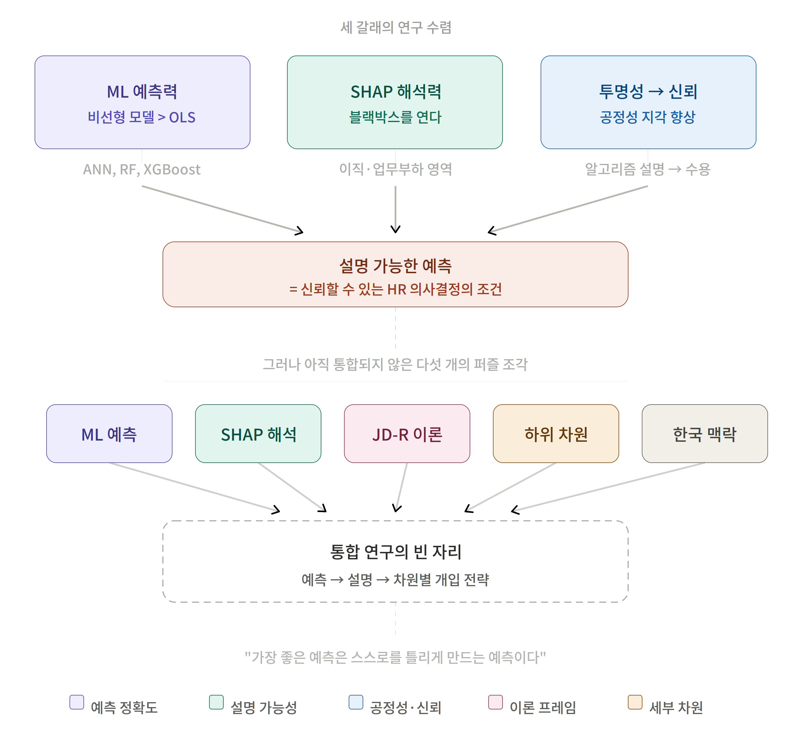

1. The First Question: “Can Job Satisfaction Be Predicted?”
Job satisfaction is an old topic. It is a staple of organizational behavior, and any HR professional has run a survey on it at least once. Yet something is strange. After decades of studying “what influences job satisfaction?”, there is almost no research that actually predicts “how will this employee’s satisfaction change next year?”
Traditional analysis relies on OLS regression. When variable A goes up by one unit, job satisfaction goes up by B. Clean. A single straight line explains everything.
The problem is that reality is not a straight line.
Somers, Birnbaum, and Casal (2021) ran OLS and an artificial neural network (ANN) on the same data simultaneously. The results differed. The effect of supervisor support on employee well-being rose up to a certain point, and beyond that threshold it stopped rising. Diminishing returns. OLS failed entirely to capture this bend, because a straight line has no bend.
Roedenbeck and Poljsak-Rosinski (2023) confirmed that an ANN achieved R²>0.75 on data from 43,000 people. It clearly outperformed the OLS baseline. Schulz et al. (2026) found something even more striking in longitudinal data from 509 firms. There was an inverted U-shaped relationship between AI adoption and job satisfaction. Adopting AI raises satisfaction up to a point, but adopting too much of it brings satisfaction back down.
This is just like a drug’s dose-response curve. The right dose heals, but an overdose becomes poison. And OLS regression flattens this curve into a straight line, concluding only that the drug “has a slight effect” — even though an optimal dose actually exists.
The first answer is this. Machine learning models can predict job satisfaction. And they do it better than traditional OLS. Consistently, across multiple studies.

2. The Second Question: “But Why Do They Do Better?”
This is where the story gets tangled.
We accept that ML models are more accurate than OLS. But we do not know why they are more accurate. Say a random forest hits R²=0.85. The HR professional will ask, “So what exactly am I supposed to do with that?”
The model does not answer. It is a black box.
Here we run into the tension between “accurate prediction” and “explainable prediction.” Benabou (2026) called this the accuracy-interpretability trade-off. Random forests and XGBoost are the most accurate but the most opaque, while decision trees (CART) are transparent but less accurate.
When I combed through 53 papers, the number that resolved this tension was two. Exactly two.
Chaudhary (2025) used a tool called SHAP for employee turnover prediction. SHAP comes from the Shapley value in game theory, and it numerically decomposes how much each variable contributed to a prediction. By analogy, it is like calculating each player’s marginal contribution to winning a soccer match. Not only the player who scored, but also the player who passed, the player who blocked on defense, and the coach who set the team tactics — each one’s share of the contribution is divided up precisely.
Sobrie (2024) combined LightGBM with SHAP in a railway traffic control setting to build a system that predicts and explains workload in real time. Instead of merely telling controllers “you are currently overloaded,” it became able to say, “this train-assignment pattern explains 73% of your workload.”
What the convergence of these two studies shows is clear. SHAP-based XAI (explainable AI) can open the black box. It preserves ML’s predictive power while explaining “why.”
But — and this is the crux — neither study targeted job satisfaction. One is about turnover, the other about workload. As far as I have read, there is not yet a study that applies SHAP to predicting job satisfaction.

3. The Third Question: “Is Job Satisfaction a Single Thing?”
This question changes everything.
Most existing research measures job satisfaction as a single score. “How satisfied are you with your current job?” From 1 to 5. But stop and think for a moment. A person who loves the work itself but is poorly paid, and a person who is paid decently but struggles with colleagues, can give the same score. Behind the number 3 lie completely different stories.
Job satisfaction has at least three sub-dimensions.
- Satisfaction with the work content: Is the work itself meaningful?
- Pay satisfaction: Is the compensation fair?
- Interpersonal satisfaction: Are relationships with the people you work with good?
Are the factors that determine these three the same? Intuitively they differ. Yet no study has predicted them separately with ML and compared the key drivers of each dimension using SHAP.
This is where Job Demands-Resources (JD-R) theory enters. The theory was originally created to explain burnout and motivation. Job resources (autonomy, supervisor support, growth opportunities) raise motivation, while job demands (overload, time pressure, emotional labor) deplete energy. It is a simple but powerful frame.
Applying this theory by twisting it onto the sub-dimensions of job satisfaction makes interesting predictions possible. For satisfaction with work content, the core drivers would be autonomy and competence development among the job resources. Pay satisfaction would be dominated by compensation fairness. Interpersonal satisfaction would be determined by social support and team cohesion.
This is a theoretical conjecture. It has not yet been empirically demonstrated. But if SHAP analysis supports this prediction, we gain two things at once: an answer to why the ML model predicts as it does, and empirical evidence that JD-R theory operates even at the sub-dimension level.

4. The Fourth Question: “Is the Prediction Fair?”
ML can predict job satisfaction. Good. SHAP can explain the reasons. Even better. But one thing remains.
Is that prediction fair?
Fabris et al. (2024) issues a direct warning. AI-based hiring systems can reproduce structural discrimination against particular groups. If there is a model that predicts highly educated men to be “more satisfied,” that is not prediction — it is the automation of prejudice.
Zheng et al. (2025) identified four “shadow experiences” of AI-HRM systems: erosion of interpersonal autonomy, surveillance-induced precarity, the algorithmic bias dilemma, and personalized dissatisfaction. It is the paradox that AI, introduced to help HR, can instead gnaw away at employees’ autonomy.
Yet Deng et al. (2025)’s finding offers a counterweight to this pessimism. Algorithmic monitoring can improve employee well-being through perceptions of organizational fairness. There is a condition, however. When it is transparent. When employees can understand why the algorithm reached the judgment it did.
SHAP is precisely the tool for this transparency. “Your pay satisfaction is predicted to be low mainly because of your compensation level relative to the same job family (contribution 42%) and the transparency of performance evaluation (contribution 28%).” If you can explain it this way, employees do not treat the algorithm as an enemy. Instead they accept it as a tool for understanding their own situation.
It is like a medical checkup. Saying only “your cholesterol is high” makes you anxious. But saying, “your LDL is 160, mainly driven by saturated-fat intake (contribution 45%) and lack of exercise (contribution 30%), and it can be improved within three months through dietary control,” leads to action. A SHAP-based explanation of job satisfaction is, in effect, the organizational version of a medical checkup report.

5. The Empty Seat: Where Is Korea?
There was corporate data from Europe, North America, Southeast Asia, and the Middle East. Korea was absent.
To be precise, there was not a single ML-based job satisfaction prediction study using Korea’s Human Capital Corporate Panel (HCCP) data. Kim (2025) analyzed job-portal text from the Korean food-service industry, but that is text data, not the multidimensional survey structure of the HCCP.
There is a reason this gap is not merely an unexamined area.
Korean organizations are different. Within a culture of high power distance and hierarchy, the quality of the supervisor-subordinate relationship may be a far stronger predictor than in Western contexts. Within the dual structure of regular and non-regular employment, employment type may be a key boundary condition that determines pay satisfaction. With the MZ generation and the baby-boom generation working in the same office, the very structure of job satisfaction may differ across generations.
There is no guarantee that patterns confirmed in the West will be reproduced in Korea. In the pathway “AI HR analytics → job crafting → resilience” proposed by Xiao, Yan, and Bamber (2025), the cultural acceptability of the act of job crafting — actively redesigning one’s own job — may be lower in high-power-distance Korean organizations than in the West. This cultural moderating effect is a distinctive question that cannot be tested except through HCCP-based research.

6. Five Methodologies Point to the Same Place
When you gather the patterns together, a remarkably consistent picture emerges.
First convergence: ML predicts better than OLS. ANN (Somers, Birnbaum, and Casal 2021), large-scale ANN (Roedenbeck and Poljsak-Rosinski 2023), GBM/XGBoost (Seo 2026), random forest (Gupta et al. 2023), multimodal deep learning (Yang 2025). The algorithms differ and the data differ, but the conclusion is the same. Nonlinear models capture the complex dynamics of job satisfaction more accurately.
Second convergence: SHAP can open the black box. Turnover prediction (Chaudhary 2025), workload prediction (Sobrie 2024). In different domains and on different models, SHAP generated explanations that HR practitioners can trust.
Third convergence: Transparency builds trust. Organizational fairness research (Deng et al. 2025), platform labor research (Jabagi 2025), decision-support experiments (Langer, Koenig, and Busch 2021). When an algorithm is explainable, employees’ perceptions of fairness and their acceptance rise.
The three streams of research converge on a single conclusion. Explainable prediction is the condition for trustworthy HR decision-making.
Yet no one has yet integrated these three streams within a single study. ML prediction + SHAP interpretation + JD-R theory + job satisfaction sub-dimensions + the Korean context. When these five puzzle pieces fit together, we can predict “why an employee is dissatisfied” in numbers, explain the reasons, and propose intervention strategies by dimension.

7. Not an End but a Beginning
There is a temptation to wrap up this piece neatly. “ML is good, SHAP is needed, Korean research is urgent.” True enough, but not sufficient.
A more provocative question remains.
In a world where ML models have come to predict job satisfaction accurately, what becomes of HR’s role? What is a manager to do upon receiving the prediction that “this employee’s satisfaction will decline within six months”? And if that intervention nullifies the model’s prediction — if satisfaction did not decline thanks to the intervention — is the model “wrong,” or has it “succeeded”?
This is the paradox of prediction. The best prediction is the one that makes itself wrong.
And one final question. When SHAP shows that “pay explains 42% of satisfaction,” will the organization actually raise pay? When data tells an uncomfortable truth, will the decision-maker follow the data, or turn off the dashboard?
It is not a problem of technology. What explainable AI ultimately poses is a question about the organization’s will.
Benabou, Samira. 2026. “Optimising HRM Practices in Call Centres: Predicting and Explaining Employee Turnover Intention Using Classification and Regression Trees.” International Journal of Organizational Analysis. https://doi.org/10.1108/IJOA-12-2024-5117.
Chaudhary, Rashmi. 2025. “An Integrated Model to Evaluate the Transparency in Predicting Employee Churn Using Explainable Artificial Intelligence.” Journal of Innovation & Knowledge 10: 100700. https://doi.org/10.1016/j.jik.2025.100700.
Deng, Huiying, Yang Lu, Di Fan, Wei Liu, and Yucheng Xia. 2025. “The Power of Precision: How Algorithmic Monitoring and Performance Management Enhances Employee Workplace Well-Being.” New Technology, Work and Employment 40 (3): 390–403. https://doi.org/10.1111/ntwe.12328.
Fabris, Alessandro, Natalia Brunner Wska, Matthew J. Dennis, David Graus, and Philipp Hacker. 2024. “Fairness and Bias in Algorithmic Hiring: A Multidisciplinary Survey.” ACM Transactions on Intelligent Systems and Technology 16 (1): Article 54. https://doi.org/10.1145/3696457.
Gupta, Aman, Aarushi Chadha, Vijay Tiwari, Arup Varma, and Vijay Pereira. 2023. “Sustainable Training Practices: Predicting Job Satisfaction and Employee Behavior Using Machine Learning Techniques.” Asian Business & Management 22 (5): 1913–36. https://doi.org/10.1057/s41291-023-00234-5.
Jabagi, Naomi. 2025. “Do Algorithms Play Fair? Analysing the Perceived Fairness of HR-Decisions Made by Algorithms and Their Impacts on Gig-Workers.” International Journal of Human Resource Management. https://doi.org/10.1080/09585192.2024.2441448.
Kim, Seonghyeon. 2025. “A Comparative Analysis of Job Satisfaction Prediction Models Using Machine Learning: A Mixed-Method Approach.” Data Technologies and Applications. https://doi.org/10.1108/DTA-10-2023-0697.
Langer, Markus, Cornelius J. Koenig, and Verena Busch. 2021. “Changing the Means of Managerial Work: Effects of Automated Decision Support Systems on Personnel Selection Tasks.” Journal of Business and Psychology 36 (5): 751–69. https://doi.org/10.1007/s10869-020-09711-6.
Roedenbeck, Marc, and Petra Poljsak-Rosinski. 2023. “Artificial Neural Network in Soft HR Performance Management: New Insights from a Large Organizational Dataset.” Evidence-Based HRM: A Global Forum for Empirical Scholarship 11 (3): 519–37. https://doi.org/10.1108/EBHRM-07-2022-0171.
Schulz, Christian, David Bendig, Alexander Braunche, and Bastian Kindermann. 2026. “Curse or Blessing: Investigating the Influence of Firms’ Artificial Intelligence Adoption on Employee Job Satisfaction.” Journal of Management Studies 63 (2): 561–95. https://doi.org/10.1111/joms.70004.
Seo, Jihye. 2026. “Using Machine Learning in HRD Research: Applications to Advance AI-Driven Organizational Analytics.” Human Resource Development International. https://doi.org/10.1080/13678868.2025.2541367.
Sobrie, Olivier. 2024. “Explainable Real-Time Predictive Analytics on Employee Workload in Digital Railway Control Rooms.” European Journal of Operational Research 312 (3). https://doi.org/10.1016/j.ejor.2023.09.016.
Somers, Mark J., Dee Birnbaum, and Jean Casal. 2021. “Supervisor Support, Control over Work Methods and Employee Well-Being: New Insights into Nonlinearity from Artificial Neural Networks.” International Journal of Human Resource Management 32 (7): 1620–42. https://doi.org/10.1080/09585192.2018.1540442.
Xiao, Qian, Jinpei Yan, and Greg J. Bamber. 2025. “How Does AI-Enabled HR Analytics Influence Employee Resilience: Job Crafting as a Mediator and HRM System Strength as a Moderator.” Personnel Review 54 (3): 824–43. https://doi.org/10.1108/PR-03-2023-0198.
Yang, Xiao. 2025. “Enhancing Employee Satisfaction and Retention via Multimodal Deep Learning in Dynamic Human Resources Decision-Making.” Journal of Organizational and End User Computing 37 (1). https://doi.org/10.4018/JOEUC.389080.
Zheng, Jie, Jie Zhen Zhang, Muhammad Mustafa Kamal, Xiaobei Liang, and Essam A. Alzeiby. 2025. “Unpacking Human-AI Interaction: Exploring Unintended Consequences on Employee Well-Being in Entrepreneurial Firms Through an in-Depth Analysis.” Journal of Business Research 196: 15. https://doi.org/10.1016/j.jbusres.2025.115406.

