What Are the Key Challenges in Implementing People/HR Analytics?
Chungil Chae
Fri, 21 November 2025
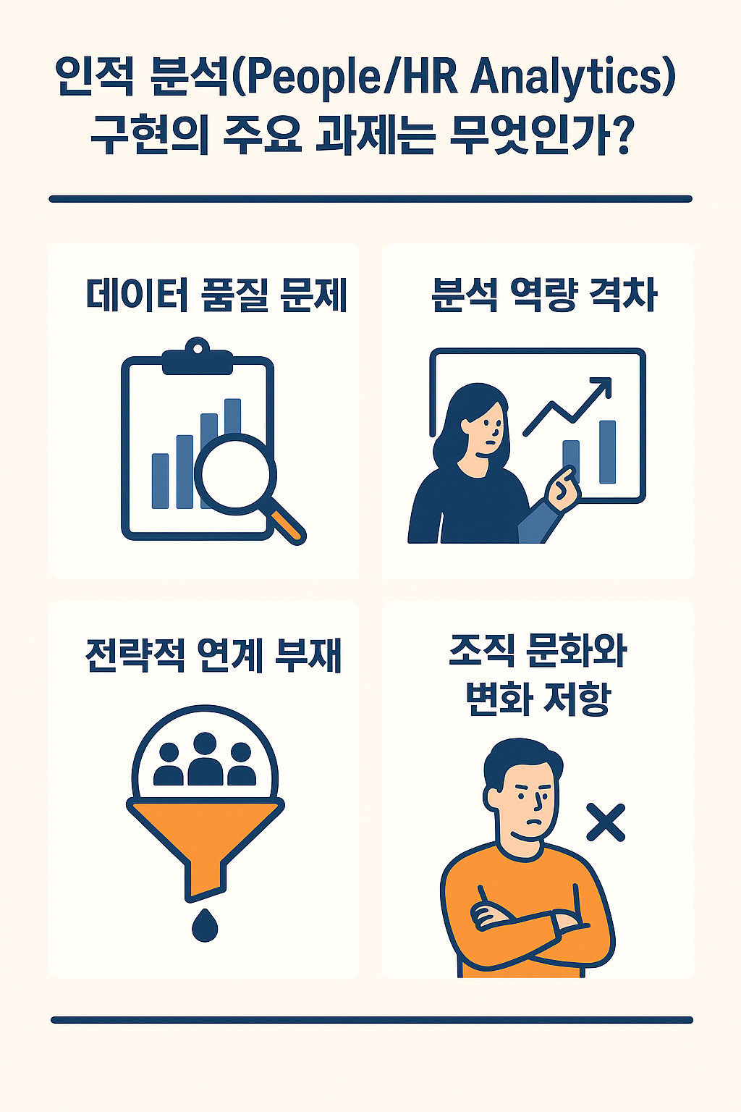

What Are the Key Challenges in Implementing People/HR Analytics?
People/HR Analytics is widely recognized as a powerful tool for transforming human resource management into data-driven decision-making. Organizations acknowledge its strategic value, with 71% of companies identifying people analytics as a top priority[1]. However, a significant gap exists between this recognition and actual implementation. Only 9% of organizations report strong understanding of performance drivers, and just 8% possess usable, high-quality data[1]. This suggests that organizations face multifaceted challenges — organizational, technical, and human — in implementing analytics. The most striking feature of HR analytics implementation is the multidimensional nature of its challenges. Minbaeva[2] defines human capital analytics as “an organizational capability grounded in three micro-level categories (individual, process, and structure) and composed of three dimensions (data quality, analytics capability, and strategic execution ability).” This framework reveals that simultaneous challenges exist across all three dimensions and that they are interconnected. The literature consistently notes that execution is more complex than technical deployment. Fernandez and Gallardo-Gallardo[3] conclude that “generally less developed forms of HR analytics emerge, due to barriers that organizations must overcome to successfully implement proper HR analytics.” In other words, many organizations can build the software and data infrastructure but struggle to translate it into actual business value. This means that simply adopting a technical system is insufficient — building capabilities across the entire organization is necessary. This essay systematically analyzes the key barriers to HR analytics implementation through a literature synthesis. Specifically, the discussion is organized around four core challenges: data quality issues, analytics capability gaps, lack of strategic alignment, and organizational culture and resistance to change, examining how these challenges constrain the development of strategic people analytics capabilities.

Data Quality and Usability Challenges
Data quality emerges as a fundamental barrier to people analytics implementation. Fernandez and Gallardo-Gallardo[3] point out that organizations struggle on two dimensions. The first is a measurement problem (“What should we measure about the workforce?”), and the second is analytical application (“How do we manage and improve the metrics deemed critical to business success?”). Karmanska[1] cites Deloitte survey results reporting that only 8% of organizations possess “usable data.” This suggests widespread data quality problems. The authors emphasize that data must go beyond merely existing — it needs to be applicable and relevant to business problems. Without proper data infrastructure and governance, organizations find it difficult to derive reliable insights to support workforce-related decisions.

Analytics Capability Gaps
Developing analytics capabilities within organizations is another critical challenge. Herden[4] notes that users “need specific knowledge of analytics to avoid errors, understand the background work and implications of analysis, and generate richer ideas about the business problems that need to be solved.” However, in practice, this level of capability is often lacking. This issue manifests at three levels. At the individual level, analytics literacy gaps are a core challenge that cannot be solved simply by hiring data scientists. At the process level, tension exists between democratization through self-service analytics and maintaining analytical rigor. Herden[4] points out that “self-service analytics initiatives require employees to develop analytics literacy, but this democratization approach requires prior analytics initiatives for that development” — presenting a chicken-and-egg dilemma. At the structural level, the challenge is that analytics capabilities must be developed not only within specialized teams but across the entire organization.

Lack of Strategic Alignment
Strategic alignment is a foundational yet frequently missing prerequisite for successful implementation. Fernandez and Gallardo-Gallardo[3] emphasize:
“HR analytics is inherently strategic and needs to go beyond the HR department silo. However, this does not mean we have already reached that stage.”
The literature identifies specific barriers related to strategic integration. First, HR professionals’ perceptions of organizational strategy significantly influence adoption. HR professionals who hold negative perceptions of their organization’s HR strategy are considerably less likely to use people data in practice, while those who perceive integration between HR strategy and business strategy are more likely to leverage people data[3]. Second, the absence of pre-defined business problems or objectives becomes a serious obstacle. Herden[4] emphasizes that this “leads to waste of resources and fosters skepticism about analytics rather than data-driven improvement.” Without clear alignment to business objectives, analytics initiatives lose purpose and organizational commitment. Third, the lack of supporting structures is problematic. Herden[4] explains that “supporting structures refer to organizational structures for data sharing, systematic processes for analysis, analytics infrastructure, and the linkage between analytics and business objectives.” Organizations often lack the foundational infrastructure — data governance frameworks, standardized processes, and technology systems — needed to support analytics initiatives.

Organizational Culture and Resistance to Change
The most paradoxical finding from the literature analysis is that the greatest obstacle to implementing analytics for human resource management is the human element itself. Beyond data systems and technical infrastructure, organizational culture and mindset emerge as critical barriers. Herden[4] identifies “willingness to collaborate, openness to change, holistic thinking, and customer-oriented mindset” as important but often absent organizational factors. The author notes that “interviewees recognized that not all elements can exist in an organization,” suggesting that cultural resistance is pervasive across many organizations. These cultural barriers manifest as a disconnect between declared priorities and actual execution. Karmanska[1] reports that “although 71% of companies recognized people analytics as a top priority within the organization, progress in adopting this trend within organizations has been slow.” Organizations acknowledge the value of analytics but struggle to embed data-driven decision-making into their organizational culture. Technical solutions alone are insufficient — organizations must build a culture that embraces data-driven decision-making.
This essay has confirmed that HR analytics implementation is a complex challenge requiring organizational transformation beyond technical deployment. Three key themes were identified: First, successful implementation means building organizational capabilities rather than deploying tools, and the three dimensions of individual, process, and structure must be addressed simultaneously. Second, the four challenges of data quality, analytics capability, strategic alignment, and organizational culture are interconnected, requiring an integrated approach. Third, the human element is both the most important and the most difficult challenge, requiring simultaneous transformation of both technology and culture. Theoretically, this study has systematized the multidimensional nature of HR analytics implementation barriers and revealed the limitations of a technology-centric perspective. Practically, it suggests that organizations should start with clearly defined business problems, secure strategic alignment, and simultaneously invest in data governance and capability development. However, the current literature explains “what the problems are” well but offers limited answers to “how to solve them.” Future research should focus on empirical analysis of success cases, tailored implementation strategies by organizational type, the evolution of barriers over time, and the development of specific change management methodologies. Ultimately, the success of HR analytics depends not on the technology itself, but on the organization’s ability to use technology effectively.

References
- Anna Karmańska (2020). The benefits of HR analytics
- Minbaeva, D. B. (2017). Human capital analytics: Why aren’t we there?
- Vicenc Fernandez; Eva Gallardo-Gallardo (2020). Tackling the HR digitalization challenge: key factors and barriers to HR analytics adoption
- T. Herden (2019). Explaining the competitive advantage generated from Analytics with the knowledge-based view: the example of Logistics and Supply Chain Management

