How Do We Measure Change in SMEs? 5 Key Findings from Latent Transition Analysis of DT Training Participants
Chungil Chae
Sun, 29 March 2026

Did the DT Training Program Really Change These Companies?

The Story of Corporate Change Through Latent Transition Analysis
Out of 282 firms participating in a DT (Digital Transformation) platform, we tracked the 47 that participated more than once to see what changed.

1. What Is This Analysis?

Think of It Like a Health Checkup
Imagine going for a health screening. At the first visit, you’re classified into one of three categories: “obese / average / healthy.” A year later, when you go back, your category might change depending on whether you exercised or changed your diet.
This analysis works exactly the same way:
- First checkup (T1) = when the firm first participated in the DT platform
- Follow-up checkup (T2) = when it participated again
- Health category = the firm’s Digital Transformation (DT) Readiness Profile
We classified firms into three types and tracked how those types changed between first participation and repeat participation.

Three Types of Firms
Type | Analogy | Characteristics
P1: Beginners | Digitally “illiterate” | Low DT awareness, no smart factory, insufficient training
P2: Transition | Digital “learners” | They know what DT is and have started, but still have a long way to go
P3: Leaders | Digital “honor students” | Smart factory adopted, automation underway, DT strategy in place
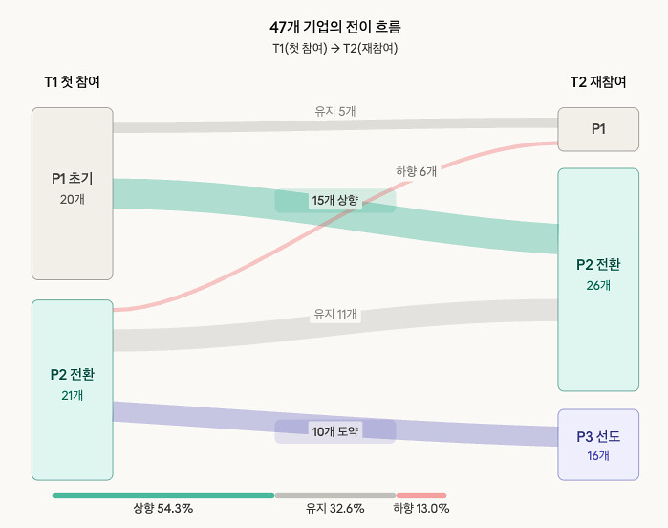

2. Did Firms Actually Improve After Training?
Statistically significant improvement was observed across all indicators.
What Was Measured | At First Visit | At Repeat Visit | How Much Did It Rise?
DT Awareness (Industry Understanding) | 2.04 | 2.48 | +0.44 (medium effect)
Awareness of Job Transition Needs | 1.96 | 2.35 | +0.40
Smart Factory Level | 1.96 | 2.33 | +0.38
Training Level | 2.52 | 3.33 | +0.81 (largest change)
Digital Automation Level | 2.33 | 2.73 | +0.40
In plain terms: repeat-participating firms improved in every area, and in particular, training level rose by 0.8 points on a 5-point scale. That’s a “fairly large” change.
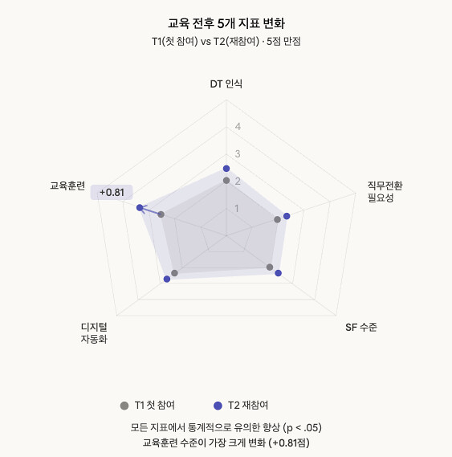

3. The Key Question: Did Firms “Level Up”?
A slight increase in numbers and an actual change in type are different things. It’s the difference between a test score going from 68 to 72, versus moving from an “F grade” to a “C grade.”

The Most Reliable Result (Alternative C)
We defined profiles using all 282 firms’ data, then tracked where each of the 47 repeat-participating firms moved.
How Did They Change? | Number of Firms | Percentage
Moved Up (to a higher type) | 25 | 54.3%
Stayed the Same | 15 | 32.6%
Moved Down (to a lower type) | 6 | 13.0%
More than half of the firms moved to a higher stage. Only 13% moved downward.

What Paths Did They Take?
Most frequent transition paths:
P1 (Beginners) ──→ P2 (Transition) 15 firms (32.6%) ★ Most common
P2 (Transition) ──→ P2 (Transition) 11 firms (23.9%) Stayed
P2 (Transition) ──→ P3 (Leaders) 10 firms (21.7%) ★★ Leap forward
P1 (Beginners) ──→ P1 (Beginners) 5 firms (10.9%) No change
Using a school analogy:
- Elementary (P1) → Middle School (P2): 32.6% — the most common growth path
- Middle School (P2) → High School (P3): 21.7% — one more step up
- Elementary (P1) → High School (P3): almost none — skipping two levels at once is virtually impossible

4. The Most Important Finding: “You Can’t Skip Stages”
This is the most powerful finding of the analysis.
Beginner (P1) firms almost never became Leaders (P3) through a single round of training.
Just as a first-grader can’t become a third-grader in one semester no matter how hard they study, digital transformation follows a step-by-step maturity path:
[P1: Beginners] ──Training 1──→ [P2: Transition] ──Training 2──→ [P3: Leaders]
"I don't even "I get it, but "We're already
know what DT is" how do we start?" doing it"
This aligns perfectly with Professor Westerman’s “Stage Theory of Digital Transformation.” To achieve DT, firms must progress through the sequence: awareness → infrastructure building → advancement.
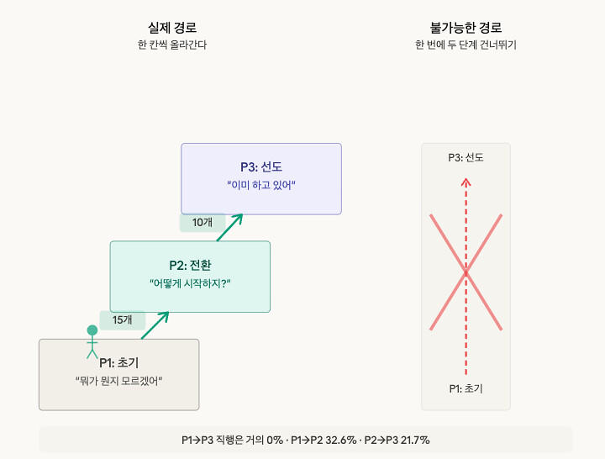

5. Which Firms Were Most Likely to Move Up?

Firms That Had Already Adopted Smart Factories (SF)
Firms with SF in place were 7.3 times more likely to move upward.
Think of it this way: someone who already has gym equipment at home gets much more out of a personal training session. This is exactly what “Absorptive Capacity” theory says — organizations that are prepared to learn absorb training far more effectively.
However, SF-adopting firms also showed higher downward movement, which is interpreted as greater volatility among firms already at higher levels.

Firms with Prior DT Training Experience?
Surprisingly, there was little effect (OR = 1.11). Having received training before doesn’t automatically push a firm upward — the content and quality of training matter more.

Firms with a Dedicated DT Department?
We expected it to act as a “safety net” preventing downward movement, but no clear effect was found. Even having a department doesn’t help if it’s not functioning effectively.
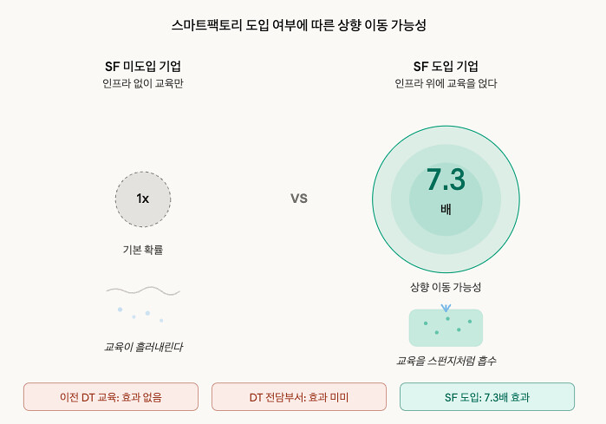

6. Can We Really Do This Analysis with Only 47 Firms?
Honest answer: It’s statistically insufficient. This type of analysis typically requires 200+ firms. Because of this limitation, we modeled results from the 47 firms that participated across all four years, supplemented by triangulation through three alternative analyses (Alternative A, B, and C) to compensate for the weakness of any single approach.
Think of it this way: it’s like dividing a school of 47 students into three classes, then checking whether anyone switched classes a year later. If only 2-3 students are in each “transition path,” it’s hard to tell whether “3 students moved from Class A to Class C” is a meaningful pattern or just coincidence.
So we asked the same question using four different methods:
Method | Core Idea | Do Results Agree?
Mplus 3-class LTA | Simultaneous estimation via statistical model | Upward trend confirmed, but unstable
Mplus 2-class LTA | Simplified to 2 groups | Difficult to interpret (label switching)
R Independent Analysis | Separate analysis at each time point, then cross-tabulation | Overestimates downward movement (methodological limitation)
Full-sample tracking (Alt C) | Classify all 282, then track the 47 | Most reliable; 54.3% upward
All four methods point to the same conclusion: an overall upward movement trend. This is called “triangulation,” and despite the weaknesses of each individual method, it strengthens the credibility of the conclusion.

7. How Should This Inform Policy?

Recommendation 1: Create “Stage-Appropriate Training Programs”
There’s no point giving Leader-level (P3) training to Beginner (P1) firms. They can’t skip stages.
Target | Training That Fits
P1 (Beginners) | “What is DT?” — Basic literacy, industry overview, case studies
P2 (Transition) | “How do we start?” — Smart factory implementation, automation adoption
P3 (Leaders) | “How do we improve?” — Advanced technology, data analytics, best practice sharing

Recommendation 2: “Infrastructure Before Training”
Firms that had already adopted smart factories saw 7x greater training impact. Bundling training programs with infrastructure development support maximizes effectiveness.
It’s like giving someone a smartphone before teaching them how to use apps — far more effective than teaching app usage to someone who doesn’t own a phone.

Recommendation 3: “Once Isn’t Enough — Bring Them Back”
P1→P2 is achievable with a single training. But P2→P3 requires repeat participation. Incentives to encourage multiple visits (priority enrollment for graduates, linked advanced courses) would be effective.

Recommendation 4: “Pay Attention to the Unchanged 10%”
Despite participating in training, 10.9% of firms remained in P1 with no change. These firms are likely in a “blind spot” of the training program. Without focused support — pre-diagnosis → tailored assistance → follow-up management — the gap between “firms that are getting better” and “firms that aren’t” will only widen.
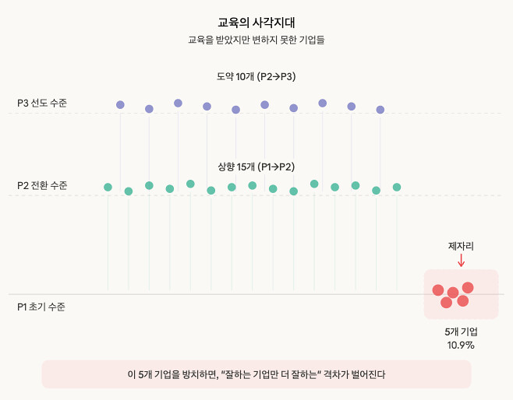

Recommendation 5: “Change How You Measure Success”
Rather than satisfaction surveys (“Did you enjoy the training?”), “Did the firm’s profile move up?” should be the performance metric. Tracking real change through follow-up measurement a year later is what genuine outcome evaluation looks like.

8. Theoretical Findings in Summary

The “Staircase Theory” (Stage Theory) — Strongest Finding
Digital transformation is a staircase, not an elevator. You have to climb one step at a time.
3F [P3: Leaders] ← Can't get here in one jump
↑ (repeat visit)
2F [P2: Transition] ← First training gets you here
↑ (first visit)
1F [P1: Beginners] ← Starting point

The “Sponge Theory” (Absorptive Capacity) — Partially Confirmed
Firms with existing infrastructure absorb training like a sponge. When a smart factory is already in place, training clicks immediately: “Oh, we can apply this to our equipment right away.” For firms with nothing, training feels like “a story from another country.”

The “Rich Get Richer” Effect (Matthew Effect) — Partially Confirmed
Firms already performing well (P3) almost never fell back (only 6.5% moved down). Once digital capabilities are built, they tend to be self-reinforcing. Meanwhile, some Beginner firms (10.9%) showed no change even after training, raising the risk of a widening gap.

9. One-Line Summary
DT training works. 54% of repeat-participating firms moved to a higher digital transformation stage. But skipping stages is nearly impossible. Stage-appropriate training is essential, and the impact is maximized in firms with existing infrastructure.

10. Caveats
We are upfront about this analysis’s limitations:
- 47 firms is a small number. These results should be read as “strong suggestions” rather than “definitive conclusions.”
- Repeat participants are a special group. Firms that come back may already be more motivated, making it difficult to generalize to all firms.
- Self-reported data. Since corporate representatives answered the surveys themselves, actual levels may differ from reported levels.
- Validated with four different methods. While no single method is conclusive, the fact that all methods point in the same direction gives confidence in the overall finding.

Analysis date: March 29, 2026 Source report: 01_LTA분석보고서.html Analysis project: T9_latent_transition (SME Transformation)

